A GRAVE MISCALCULATION
TEXT: Thus saith the Lord GOD of hosts, Go, get thee unto this treasurer, even unto Shebna, which is over the house, and say, What hast thou here? and whom hast thou here, that thou hast hewed thee out a sepulchre here, as he that heweth him out a sepulchre on high, and that graveth an habitation for himself in a rock? Behold, the LORD will carry thee away with a mighty captivity and will surely cover thee. (Isa 22:15-17)
INTRODUCTION:
- Curious grave epitaphs.
  - Jesse James
“Murdered by a traitor and coward whose name is not worthy to appear here”
  - Mel Blanc
“That’s all, folks”
  - Rodney Dangerfield
“…There goes the neighborhood”
  - Joan Hackett
“Go away – I’m asleep”
  - Bette Davis
“She did it the hard way”
  - Martin Luther King Jr.
“Free at last, Free at last, Thank God Almighty I’m Free at last” z
- The grave of James Breathed M.D.
  - Biography:
Maj. James Breathed was born near present-day Berkeley Springs, W. Va., on December 15, 1838, and moved while young with his family to Washington Co., Md. He attended St. James School in Lydia, where his father John Breathed was headmaster. At age 21, he graduated from the University of Maryland Medical School. The son of John William Breathed and Ann McGill Williams.

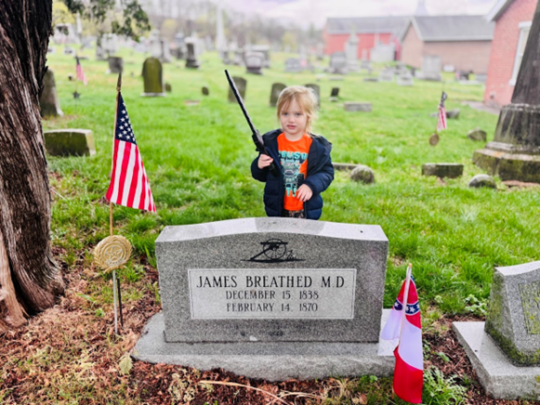
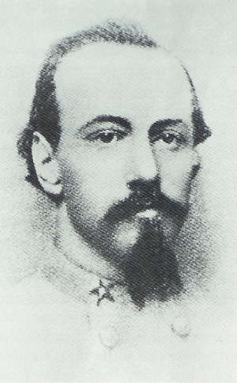

When the conflict started, he was practicing medicine in Saint Joseph, Missouri, he was compelled to enlist in the Army of Northern Virginia. Enlisted April 19,1861, at Martinsburg, (West) Virgina as a Private in Company B, 1st Virginia Cavalry Regiment. Transferred to General J.E.B. Stuart's Horse Artillery, November 20, 1861. Promoted to 1st Lieutenant, Pelham's Battery, March 23, 1862. Promoted to Captain August 9, 1862. Promoted to Major of Artillery, February 27, 1864. Commanded the Battalion of Stuart's Horse Artillery until wounded in action at Yellow Tavern, Viginia May 11, 1864. Wounded in action a second time June 24, 1864. Paroled in Winchester, Virginia, April 24, 1865. He fought at the forefront in 15 battles, was considered by many to be the hardest artillery fighter in the Army of Northern Virginia. At the conclusion of the war, Doctor Breathed lived with his sister, Priscilla Williams Breathed Bridges and spent his remaining days, practicing medicine at Hancock, Washington County, Maryland. The epitaph of his tombstone reads,” Major James Breathed of Stuart's Horse Artillery, Army of Northern Virginia, the hardest Artillery fighter the war produced."

Major James Breathed was awarded the Confederate Medal of Honor posthumously in October 2013. He was 1 out only 48 Confederate soldiers who earned this award.


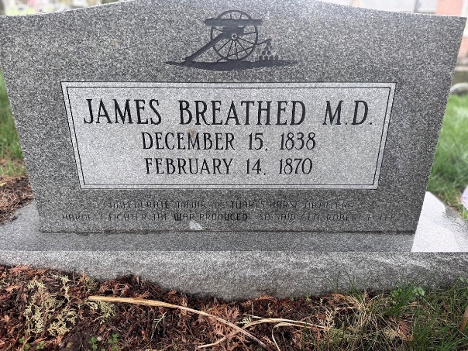

- Shebna’s Grave.
  - Shebna's Actions:
    - Isaiah confronts Shebna, a high-ranking official, for his actions, specifically carving out a tomb for himself, a practice usually reserved for royalty.
    - Isaiah prophesies that Shebna's position will be taken by Eliakim, and that Shebna will be cast out and die in exile.
    - Isaiah's rebuke highlights Shebna's vanity and ambition, suggesting that he was more concerned with his own legacy and status than with serving God or the king.
    - Eliakim is mentioned as the replacement for Shebna, and he is described as a more faithful and capable servant of God.
  - Rock-Cut Tomb:
    - The act of carving a tomb in rock was a practice associated with royalty and those of high status in the ancient Near East.
    - Some scholars believe that a rock-cut tomb discovered in Silwan, near Jerusalem, might be Shebna's, with an inscription mentioning "yahu who is over the house" [6, 8, 14]., The inscription, now in the British Museum, is believed to be part of Shebna's tomb [6, 8, 14].
    - Isaiah 22:15-25:
    - These verses conclude Isaiah's oracle against Jerusalem, focusing on Shebna and Eliakim, with Shebna's actions and the prophecy against him serving as a warning against pride and ambition.
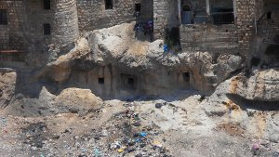
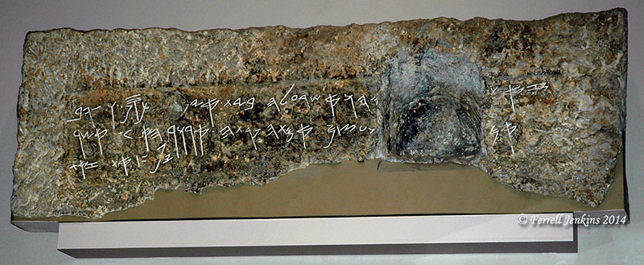
- HISTORICAL SETTING
  - Shebna
    - We have before us a prophecy concerning two individuals, which is a rare subject in Isaiah, for he dealt mainly with nations.
    - But in his case, God chose to bring to light broader principles by singling out a man who represented evil within the Jewish nation.
    - The prophecy is against Shebna, an officer in the court of Hezekiah, a good and noble king.
    - Shebna was a wicked, deceitful, and proud man who, as some Jewish historians maintain, conspired with Assyria in an attack on Jerusalem.
    - Shebna probably was elevated to his position as household treasurer during the reign of Hezekiah’s father, Ahaz.
  - God’s Judgement
    - The Lord saw Shebna’s pride and wickedness, and He sent Isaiah to proclaim judgment on him.
    - The main point of the prophecy was that Shebna would be brought down and another man, Eliakim, would be put in his place over the household.
    - Eliakim was a servant of the Lord, faithful and trustworthy, and he would rise from a lower position to become a great officer in the court.
  - Shebna’s reliance
    - This probably seemed ridiculous to Shebna at the time because he believed himself rooted in his position.
    - He even had a sepulcher hewn out for himself as a monument to his greatness.
    - He was ambitious to be remembered and honored even after his death. Shebna was full of his own glory, but God was not impressed, and He would not tolerate a traitor amid His people.
    - He would replace Shebna, bringing him down from his lofty position to that of a scribe, and then eventually sending him from the country to die in a foreign land, alone and forgotten.
    - Some Jewish historians believe Shebna contracted leprosy and was forced from the court and eventually from the nation because the disease was seen as a direct judgment of God.
    - If this was what happened, then God’s judgment was complete, for a “great” man was brought low without hope of redemption.

- Grave Mistakes in the Bible
  - Uzziah – 2 Chronicles 26:21-23
    - Affliction with Leprosy:
- In 2 Chronicles 26:21 the Bible states, " And Uzziah the king was a leper unto the day of his death, and dwelt in a several house, being a leper; for he was cut off from the house of the LORD: and Jotham his son was over the king's house, judging the people of the land".
    - Separation and Exclusion:
- The text emphasizes that Uzziah was "cut off from the house of Yahweh" (Temple) and lived in a separate house, indicating his isolation and exclusion from the royal duties and religious life.
    - Burial:
- When Uzziah died, he was buried in a field belonging to the kings, but not in the royal cemetery, because he had leprosy.
- Jotham, Uzziah's son, took over the king's duties and ruled the people of the land.
- 2 Chronicles 26:23 says that " So Uzziah slept with his fathers, and they buried him with his fathers in the field of the burial which belonged to the kings; for they said, He is a leper: and Jotham his son reigned in his stead."
  - Hamman – Esther 5:14
    - Hamman indulged in visions of grandeur, but they were brought to nought.
- Then said Zeresh his wife and all his friends unto him, Let a gallows be made of fifty cubits high, and to morrow speak thou unto the king that Mordecai may be hanged thereon: then go thou in merrily with the king unto the banquet. And the thing pleased Haman; and he caused the gallows to be made. (Est 5:14)
- He was comfortable in the palace.
- His arrogance left no room for altruism.
    - God had different plans in store for Hamman.
- Hammon had hatched this diabolical plot to kill Mordecai but the tables were turned.
- And Harbonah, one of the chamberlains, said before the king, Behold also, the gallows fifty cubits high, which Haman had made for Mordecai, who had spoken good for the king, standeth in the house of Haman. Then the king said, Hang him thereon. So they hanged Haman on the gallows that he had prepared for Mordecai. Then was the king's wrath pacified. (Est 7:9-10)
  - The Rich Fool – Luke 12:13-21
    - The Abundant Harvest:
- The parable begins with a rich man whose land yields a bountiful harvest, leaving him with more crops than he can store in his existing barns.
- He thinks to himself, "What shall I do, because I have no room where to store my crops?" and decides to tear down his barns and build larger ones to store all his grain and goods.
    - The Foolish Plan:
- He then plans to say to his soul, "Soul, you have many goods laid up for many years; take your ease, eat, drink, and be merry".
- However, God intervenes and says to the man, "You fool! This very night your life is being demanded of you. And the things you have prepared, whose will they be?".
    - Lesson:
- The parable serves as a cautionary tale about the dangers of materialism and greed, emphasizing that true wealth lies not in earthly possessions but in spiritual riches and a relationship with God.
- The parable highlights the dangers of focusing on accumulating possessions and ignoring spiritual needs.
- The focus is on the importance of a relationship with God and living a life of purpose, rather than accumulating wealth.
- The parable reminds us that life is fleeting and that we should not become so focused on earthly possessions that we forget about eternity.
  - Many - Matthew 7:21-23
    - In Matthew 7:21-23, Jesus warns that simply claiming "Lord, Lord" or performing miracles in His name isn't enough for entry into heaven; true faith and obedience to God's will are essential.
- Jesus gives a Warning: "Not everyone who says to me, 'Lord, Lord,' will enter the kingdom of heaven, but only the one who does the will of my Father in heaven".
- He then describes a scenario where people will come to Him on the final day, claiming to have prophesied, cast out demons, and performed miracles in His name.
- However, Jesus will declare, "I never knew you; depart from me, you workers of lawlessness".
    - The Key:
- The passage emphasizes that outward actions or claims are not sufficient for salvation; instead, it highlights the importance of genuine faith and obedience to God's will.
- This passage is part of the Sermon on the Mount, where Jesus teaches about true discipleship and the importance of living a life that reflects one's faith.
- The verses preceding 7:21-23 warn about false prophets and the importance of recognizing them by their fruit, meaning their actions and choices.
- Jesus defines true belief as beginning with true belief, which is to believe in God's Son.
CONCLUSION:
- James Breathed was poised to be a great leader amongst the confederate states, but circumstances would intervene to destroy the southern cause.
- He would not let this setback define him and would go on to humbly serve this community as a beloved doctor.
- He received little recognition during his life, but history has promoted him as a true pillar.
- Shebna held the highest position just under the king and made plans to secure his house and his legacy but building a great tomb amongst the kings.
- Then came forth unto him Eliakim, Hilkiah's son, which was over the house, and Shebna the scribe, and Joah, Asaph's son, the recorder. (Isa 36:3)
- He is demoted by the king and never again is placed in his former role.
- He will die in captivity and will never rest in his grand tomb.

